Comprehensive School Improvement Plan

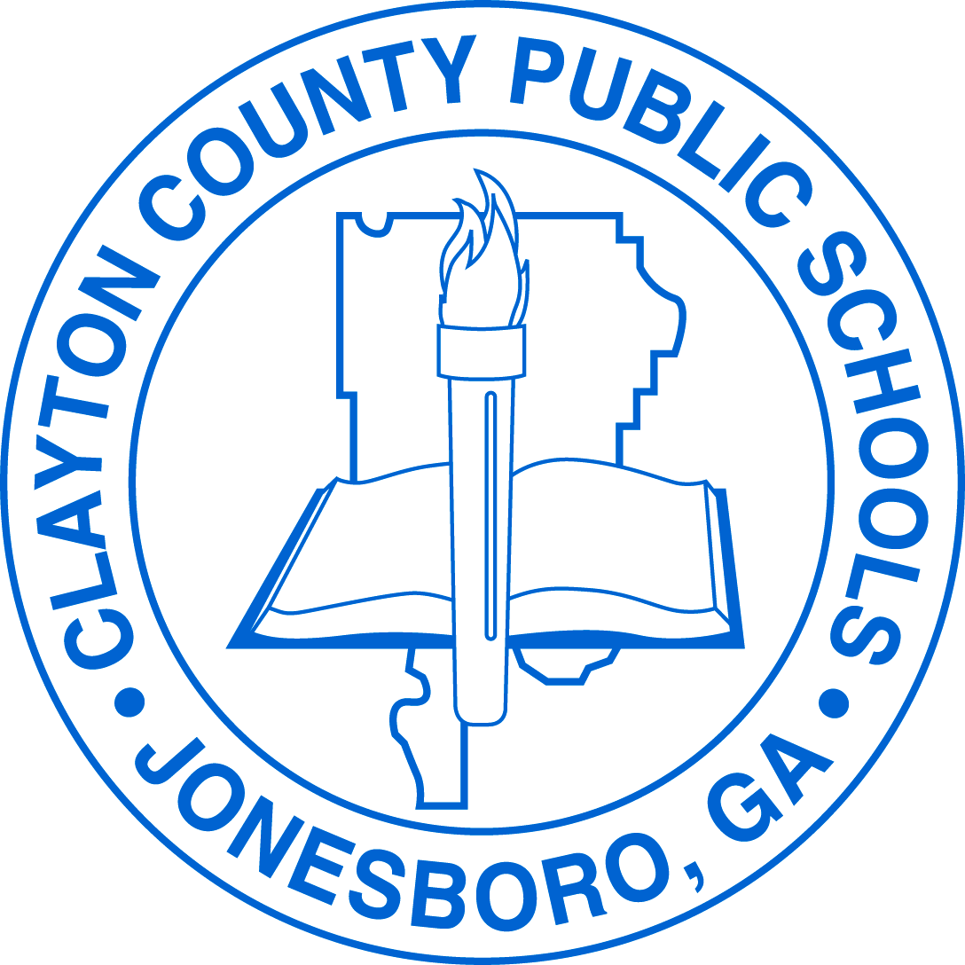

William M. McGarrah Elementary School

2019-2020

Vision Statement
The vision of Clayton County Public Schools is to be a district of high performance ALL students
to live and compete successfully in a global society.

Mission Statement
The mission of Clayton County Public Schools is to empower students to achieve academic and personal goals.

CCRPI
School Year | CCRPI Score | Content Mastery | School Progress | Closing the Gaps | Readiness | Climate Rating | Star Rating | PPE Percentile  (Per Pupil Expenditure)
2017-2018 | 76.5 | 58.2 | 85.1 | 93.8 | 75.8 | 89.8 | 3 | 43rd
2018-2019 | 70.4 | 58.4 | 89.7 | 43.8 | 74.6 | 93.8 | 4

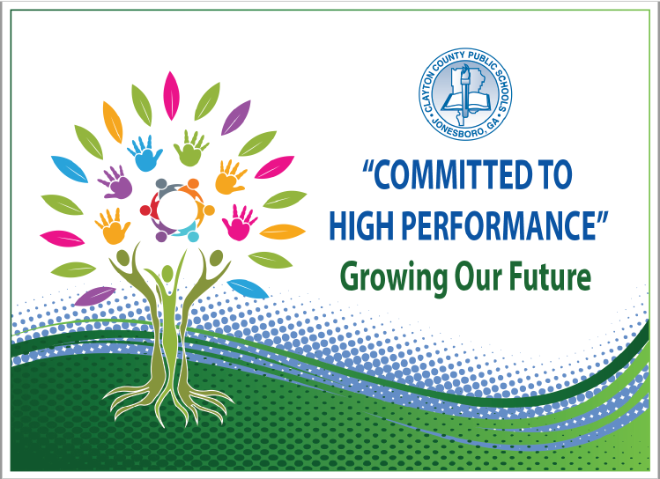
Strategic Goals
To increase academic achievement for all students in Clayton County Public Schools as evidenced by state, national, and international assessment results
To provide and maintain a safe and orderly learning environment
To create an environment that promotes active engagement, communication, accountability, and collaboration of all stakeholders to maximize student achievement
To provide high quality support services delivered on time and within budget to promote high performance in the Clayton County Public Schools
To recruit, develop, and retain highly qualified and effective staff

Action Plan

Performance Objective 1: By 2023, Clayton County Public Schools will increase the percentage of students scoring at the Proficient and/or Distinguished levels on the Georgia Milestones to at least 80% in each content area.
GADOE School Improvement Systems: Coherent Instruction, Effective Leadership, Family and Community Engagement, Professional Capacity
Action Steps/ Tasks |  | Timeline | Project Leader(s) and School Level Person(s) Monitoring | Resources/ Funding | Check Points/ Related Artifacts and Evidence | Professional Learning  Activity and Date  (where applicable)
Sustaining a Culture of Writing a  across the curriculum |  | August, 2019 - May, 2020 | Administrators, Academic Coach, Counselor | General Fund | Monthly Checkpoints
A. | Implement the K-5 Writing Plan | August, 2019 | Administrators, Academic Coach, All Classroom Teachers | General  Funds | Evidence of writing samples, writing rubrics and lesson plans | \
B. | Teachers collected a beginning of the year writing samples and establish a writing baseline. | August, 2019 | Academic Coach  All Classroom Teachers | General  Funds | Evidence of writing samples and student conferences
C. | Vocabulary/Word Walls in ALL classes including Specials (Art, Music, PE) classes and the computer labs | September, 2019 | Academic Coach, Classroom Teachers | General  Funds | Evidence in classrooms as seen through walk-throughs, photos of word walls | August 27th during P.A.W.S  (Specials Teachers at 8:00)
D. | School wide story…The Adventure of William! | September, 2019 | Academic Coach, Classroom Teachers | General  Funds | Evidence of story written on chart paper in school hallways. Classes will be assigned by academic coach. Teachers will be able to follow the Adventures of William Writing Calendar. | McGarrah University, August 2, 2019
E. | Professional development will be provided to teachers in areas of writing and vocabulary | September, 2019 | Academic Coach  District ELA Lead  3 -5 grade teachers | General  Funds | Evidence will be presentations, agendas, sign-in, evaluations | September 9, 2019- Effective Strategies to teach Vocabulary (3rd-5th teachers).
F. | Effective Writing Strategies Across the Curriculum…Writing Process Instructional Plan | November, 2019 | Academic Coach  Writing Team | General Funds | Evidence will be presentations, agendas, sign-in, evaluations | November 4, 2019  Faculty Meeting
G. | Planning and Analyzing Writing Samples | November, 2019 | Academic Coach  Teachers | General Funds | Evidence will be writing samples, graphic organizers, templates, writing rubrics
Mapping Our Way Through Assessments |  | August 2019 -  May, 2020 | Academic Coach  Administrators | General Funds | Monthly Checkpoints
A. | Teachers received training on Illuminate and MAP (Measures of Academic Progress) platforms for assessment purposes | August, 2019 | Illuminate and MAP Contacts  Academic Coach | General Funds | Contacts will continue to work with teachers on the new platforms when needed. | July 30, 2019  August 8, 2019
B. | Students in grades 3 - 5 to take Benchmark Assessments on MAP platform | August, 2019 | Classroom Teachers | General  Funds | Class roster completion | August 12 - 16, 2019
C. | Teachers have attended training on new DIBELS 8 edition and GKIDS 2.0 assessments. | August , 2019 | Assistant Principal  EIP Lead Teacher  K/1 teachers | General  Funds | Agendas, sign-in sheets, powerpoint presentations | August 1, 2019  August 19, 2019  September 16, 2019
D. | Teachers will map assessments on our school-wide data excel spreadsheet and present information from student assessments, lexile, absences, etc. | Beginning September 2019 | Administrators and Teachers | General Funds | Agendas, sign-in sheets, data presentations/excel spreadsheets | September 12, 2019
E. | Creating assessments in Illuminate | November, 2019 | Academic Coach | General Funds | Agendas, sign-in sheets

Supplemental Supports: What supplemental action steps will be implemented for these subgroups?
Economically Disadvantaged | Foster and Homeless
Differentiated and small group instruction targeting student deficit areas. | Students will receive the same services as Economically Disadvantaged students.
English Learners | Migrant
- Imagine Learning
- Continue to develop language standards with teachers to implement in the classroom with access to writing across the curriculum.
- Increase vocabulary by using domain specific vocabulary and displaying during academic discourse.

Race/Ethnicity/Minority | Students with Disabilities
Differentiated and small group instruction targeting student deficit areas | - Small group instruction with explicit instructions for writing strategies.  - Promote writing through corrective reading strategies.  - Increase vocabulary by using domain specific vocabulary and displaying during academic discourse

Performance Objective 2: Over the next five years, Clayton County Public Schools will increase the graduation rate from 69.6% to 90% or higher.
GADOE School Improvement Systems: Coherent Instruction, Effective Leadership, Family and Community Engagement, Professional Capacity
Action Steps/ Tasks |  | Timeline | Project Leader(s) and School Level Person(s) Monitoring | Resources/ Funding | Check Points/ Related Artifacts and Evidence | Professional Learning  Activity and Date  (where applicable)
Creating a Culture of Rigor and Relevance
A. | Introduce learner engagement rubric from ICLE and explain how this rubric will be our RIGOR focus for the first few months of school. | August, 2019 | Administration  Academic Coach | General Funds | Sign in, PowerPoint, handouts | McGarrah University 8-2-2019
B. | Teachers will perform a CLOSE READ of the Learner Engagement Rubric from ICLE and develop effective active participation, learner environment and formative assessment protocols as it relates to the learner engagement rubric | August -October, 2019 | Administration  Academic Coach | General Funds | 10 min walkthroughs feedback (Looks like, sounds like, feels like), P.A.W.S (Professionals at Work Session) handouts, agendas, sign-ins, pictures, videos | 8-27-19 P.A.W.S.
C. | Academic Coach provides instructional strategies and tips to provide support with learner engagement in the class. | August, 2019 | Academic Coach | General Funds | CIA Weekly updates newsletter
D. | Introduce the Relevance Rubric and how to create relevance for the students during the lesson. | November, 2019 | Academic Coach | General Funds | Sign n sheets, PowerPoint, handouts

Supplemental Supports: What supplemental action steps will be implemented for these subgroups?
Economically Disadvantaged | Foster and Homeless
Differentiated and small group instruction targeting student deficit areas. | Students will receive the same services as Economically Disadvantaged students.
English Learners | Migrant
- Imagine Learning
- Continue to develop language standards with teachers to implement in the classroom with access to writing across the curriculum.
- Increase vocabulary by using domain specific vocabulary and displaying during academic discourse.

Race/Ethnicity/Minority | Students with Disabilities
Differentiated and small group instruction targeting student deficit areas | - Small group instruction with explicit instructions for writing strategies.  - Promote writing through corrective reading strategies.  - Increase vocabulary by using domain specific vocabulary and displaying during academic discourse

Performance Objective 3: By 2023, Clayton County Public Schools will increase the number of students absent less than 10% of their enrolled academic year.
GADOE School Improvement Systems: Effective Leadership, Supportive Learning Environment, Family and Community Engagement, Professional Capacity
Action Steps/ Tasks | Timeline | Project Leader(s) and School Level Person(s) Monitoring | Resources/ Funding | Check Points/ Related Artifacts and Evidence | Professional Learning  Activity and Date  (where applicable)
Implement Attendance Matters Campaign | August, 2019 -  May, 2020 | Counselor  Administrators  School Social Worker | General Funds | Monthly Checkpoints
- Establish an Attendance Committee | August, 2019 | Counselor  Social Worker  Teachers | General Funds | Meeting agendas, sign-in sheets
B. Attendance Awareness Month | September, 2019 | Counselor  Administrators  Teachers | General Funds | Calling post message to parents, morning and afternoon announcements,
- SAC meetings with parents | September, 2019 | Attendance Committee | General Funds | Attendance letters, Documentation in IC
- Attendance Week Campaign | October, 2019 | Counselor, Administrators,  Teachers | General Funds | Attendance announcements, attendance posters, attendance student particiaption

Supplemental Supports: What supplemental action steps will be implemented for these subgroups?
Economically Disadvantaged | Foster and Homeless
All students will benefit from the initiatives that will be implemented. | All students will benefit from the initiatives that will be implemented.
English Learners | Migrant
All students will benefit from the initiatives that will be implemented. | All students will benefit from the initiatives that will be implemented.
Race/Ethnicity/Minority | Students with Disabilities
All students will benefit from the initiatives that will be implemented. | All students will benefit from the initiatives that will be implemented.

Performance Objective 4: By 2023, Clayton County Public Schools will decrease the number of discipline infractions while increasing employee morale and community support.
GADOE School Improvement Systems: Effective Leadership, Supportive Learning Environment, Family and Community Engagement, Professional Capacity
Action Steps/ Tasks | Timeline | Project Leader(s) and School Level Person(s) Monitoring | Resources/ Funding | Check Points/ Related Artifacts and Evidence | Professional Learning  Activity and Date  (where applicable)
Increase Positive Reinforcement School-Wide | August, 2029 -  May, 2020 | Administrators  Counselor  SST Chairs | General Funds | Monthly Checkpoints
- Establishing professional decorum, safe and orderly learning environments and social/emotional cues were discussed;  All homeroom teachers contacted parents to provide a “welcome back to the new school year” and to answer any immediate questions they may have had. | August, 2019 | Administrators | General Funds | Walkthroughs/Observations, Office Referrals, Parent Contact Log | McGarrah University  August 2, 2019
B. Implement “Pop Up PAW Praise” monthly rewards | Monthly, beginning August 2019 | Assistant Principal | General Funds | Cats Cash | Ongoing, Monthly
C. Monthly article/literature on positive reinforcement provided to staff to further educate on the benefits of using positive reinforcement | Each month beginning September 2019 | Assistant Principal | General Funds | Article handout or link provided during grade level meetings | Monthly
D. Monthly C.I.A. (Curriculum,  Instruction, Assessment) shout-outs | During monthly staff meetings, beginning August 2019 | McIntyre-Academic Coach | General Funds | Monthly staff meeting agendas
E. PAW store | November, 2019 | Assistant Principal  Discipline Committee | General Funds | Students spend Cat Cash at the PAW Store
F. DoJo Shout outs-85% or better average for class dojo points | November, 2019  (weekly) | Assistant Principal  Discipline Committee | General Funds | Shout-out occur during morning announcements

Supplemental Supports: What supplemental action steps will be implemented for these subgroups?
Economically Disadvantaged | Foster and Homeless
Continue to reinforce in all content settings expectations for behavior and allowing students opportunities to provide dialogue on appropriate and inappropriate behaviors. | Continue to reinforce in all content settings expectations for behavior and allowing students opportunities to provide dialogue on appropriate and inappropriate behaviors.
English Learners | Migrant
Continue to reinforce in all content settings expectations for behavior and allowing students opportunities to provide dialogue on appropriate and inappropriate behaviors. | Continue to reinforce in all content settings expectations for behavior and allowing students opportunities to provide dialogue on appropriate and inappropriate behaviors.
Race/Ethnicity/Minority | Students with Disabilities
Continue to reinforce in all content settings expectations for behavior and allowing students opportunities to provide dialogue on appropriate and inappropriate behaviors. | Continue to reinforce in all content settings expectations for behavior and allowing students opportunities to provide dialogue on appropriate and inappropriate behaviors.

